A gyroscope is a device used primarily for navigation and measurement of angular velocity Gyroscopes are available that can measure rotational velocity in 1, 2, or 3 directions. 3-axis gyroscopes are often implemented with a 3-axis accelerometer to provide a full 6 degree-of-freedom (DoF) motion tracking system.

Gyroscopes have evolved from mechanical-inertial spinning devices consisting of rotors, axles, and gimbals to various incarnations of electronic and optical devices. Each exploits some physical property of the system allowing it to detect rotational velocity about some axis. There are three basic types of gyroscope:

* Rotary (classical) gyroscopes
* Vibrating Structure Gyroscope
* Optical Gyroscopes

Rotary Gyroscope

The classic gyroscope exploits the law of conservation of angular momentum which, simply stated, says that the total angular momentum of a system is constant in both magnitude and direction if the resultant external torque acting upon the system is zero[4)](http://sensorwiki.org/doku.php/sensors/gyroscope" \l "fn__4). These gyroscopes typically consist of a spinning disk or mass on an axle, which is mounted on a series of gimbals. Each gimbal offers the spinning disk an additional degree of rotational freedom. The gimbals allow the rotor to spin without applying any net external torque on the gyroscope. Thus as long as the gyroscope is spinning, it will maintain a constant orientation. When external torques or rotations about a given axis are present in these devices, orientation can be maintained and measurement of angular velocity can be measured due to the phenomenon of precession.

Precession occurs when an object spinning about some axis (the spin axis) has an external torque applied in a direction perpendicular to the spin axis (the input axis). In a rotational system when net external torques are present, the angular momentum vector (which is along the spin axis) will [Gimballed gyroscope, showing how each gimbal offers an additional degree of rotational freedom. Taken from http://commons.wikimedia.org/wiki/File:Gyroscope_operation.gif
](http://sensorwiki.org/lib/exe/detail.php/sensors/gyroscope_operation.gif?id=sensors%3Agyroscope&cache=cache)move in the direction of the applied torque vector. As a result of the torque, the spin axis rotates about an axis that is perpendicular to both the input axis and spin axis (called the output axis).

[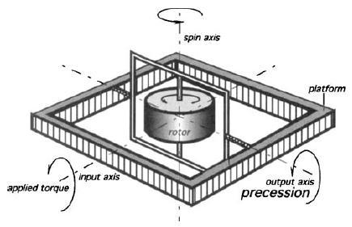](http://sensorwiki.org/lib/exe/detail.php/sensors/gyroscope_axes_crop.jpg?id=sensors%3Agyroscope&cache=cache)

For the animation refer to the following link:

http://sensorwiki.org/lib/exe/detail.php/sensors/gyroscope\_operation.gif?id=sensors%3Agyroscope&cache=cache

This rotation about the output axis is then sensed and fed back to the input axis where a motor or similar device applies torque in the opposite direction, cancelling the precession of the gyroscope and maintaining its orientation. This cancellation can also be accomplished with two gyroscopes oriented at right angles to one another.

To measure rotation rate, counteracting torque is pulsed at regular time intervals. Each pulse represents a fixed angular rotation δθ, and the pulse count in a fixed time interval t will be proportional to the net angle change θ over that time period – thus, the applied counteracting torque is proportional to the rotation rate to be measured3).

Today rotary gyroscopes are mainly used in stabilization applications. The presence of moving parts (gimbals, rotors) means that these gyroscopes can wear out or jam. A number of bearing types have been developed to minimize the wear and chance for jamming in these gyroscopes Another consequence of moving parts is that it limits how small these gyroscopes can be. Thus rotary gyroscopes are mostly used today in harsh military and naval environments which are subject to shock and intense vibration, and where physical size is not critical. These units are therefore not readily commercially available.

Vibrating Structure Gyroscope

Vibrating structure gyroscopes are MEMS (Micro-machined Electro-Mechanical Systems) devices that are easily available commercially, affordable, and very small in size. Fundamental to an understanding of the operation of an vibrating structure gyroscope is an understanding of the Coriolis force. In a rotating system, every point rotates with the same rotational velocity. As one approaches the axis of rotation of the system, the rotational velocity remains the same, but the speed in the direction perpendicular to the axis of rotation decreases. Thus, in order to travel in a straight line towards or away from the axis of rotation while on a rotating system, lateral speed must be either increased or decreased in order to maintain the same relative angular position (longitude) on the body. The act of slowing down or speeding up is acceleration, and the Coriolis force is this acceleration times the mass of the object whose longitude is to be maintained. The Coriolis force is proportional to both the angular velocity of the rotating object and the velocity of the object moving towards or away from the axis of rotation.

[](http://sensorwiki.org/lib/exe/detail.php/sensors/corioliskraftanimation.gif?id=sensors%3Agyroscope&cache=cache)

[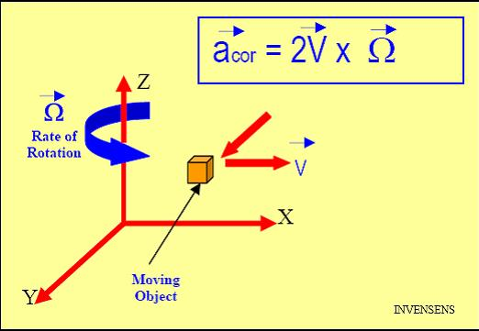](http://sensorwiki.org/lib/exe/detail.php/sensors/gyroscope_coriolis_accel.jpg?id=sensors%3Agyroscope&cache=cache)

Vibrating structure gyroscopes contain a micro-machined mass which is connected to an outer housing by a set of springs. This outer housing is connected to the fixed circuit board by a second set of orthogonal springs.

[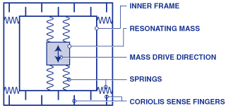](http://sensorwiki.org/lib/exe/detail.php/sensors/gyro_vsg1.gif?id=sensors%3Agyroscope&cache=cache)

The mass is continuously driven sinusoidally along the first set of springs. Any rotation of the system will induce Coriolis acceleration in the mass, pushing it in the direction of the second set of springs. As the mass is driven away from the axis of rotation, the mass will be pushed perpendicularly in one direction, and as it is driven back toward the axis of rotation, it will be pushed in the opposite direction, due to the Coriolis force acting on the mass.

[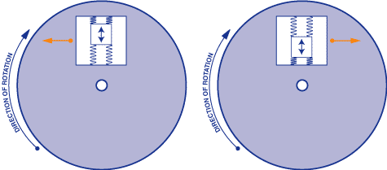](http://sensorwiki.org/lib/exe/detail.php/sensors/gyro_vsg2.gif?id=sensors%3Agyroscope&cache=cache)  
The Coriolis force is detected by capacitive sense fingers that are along the mass housing and the rigid structure. As the mass is pushed by the Coriolis force, a differential capacitance will be detected as the sensing fingers are brought closer together. When the mass is pushed in the opposite direction, different sets of sense fingers are brought closer together; thus the sensor can detect both the magnitude and direction of the angular velocity of the system [7)](http://sensorwiki.org/doku.php/sensors/gyroscope" \l "fn__7) .   
[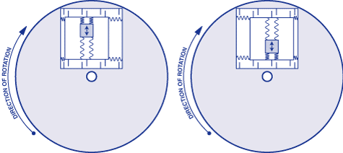](http://sensorwiki.org/lib/exe/detail.php/sensors/gyro_vsg3.gif?id=sensors%3Agyroscope&cache=cache)

Optical Gyroscope

Optical gyroscopes were developed soon after the discovery of laser technology. The appeal of this type of gyroscope is that they contain no moving parts, and hence are not susceptible to mechanical wear or drifting. Optical gyroscopes differ from other types in that they do not rely on conservation of angular momentum in order to operate. Instead, their functionality depends only on the constancy of the speed of light.

Optical gyroscopes operate under the principle of the Sagnac effect. It easiest to understand this principle in the general case of a circle. A light source is positioned on a circle, emitting two beams of light in either direction. If the source stays stationary, then both beams of light require an equal amount of time to traverse the circle and arrive back at the source. However, if the source is rotating along the circle, then it takes more time for the beam in front of the source to complete its path.

[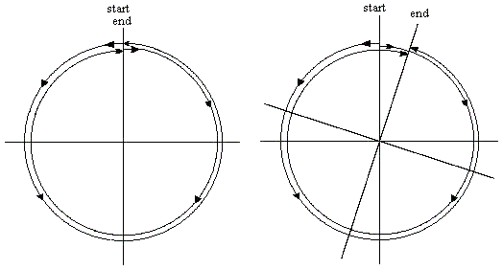](http://sensorwiki.org/lib/exe/detail.php/sensors/sagnac_effect.gif?id=sensors%3Agyroscope&cache=cache)

This principle can in fact be generalized to any loop, regardless of shape. In particular, we can measure the effect using a ring interferometry setup. Here, a laser beam is first split by a half silvered mirror. Then the two beams traverse identical paths but opposite directions around a loop consisting of either flat mirrors and air-filled straight tubes or a long fibre-optic cable. These two beams then recombine at a detector. When the system is rotating, one of the beams must travel a greater distance than the opposite traveling beam to make it to the detector. This difference in path length (or Doppler shift) is detected as a phase shift by interferometry. This phase shift is proportional to the angular velocity of the system5). Often optical gyroscope units consist of 3 mutually orthogonal gyroscopes for rotation sensing about all three orthogonal rotation axes. They are also typically implemented with 3-axis accelerometers thus providing full motion sensing in 6 DoF. Like rotor gyroscopes, optical gyroscopes are limited in how physically small they can get, due to the extensive amount of fibre-optic cable needed and presence of optical equipment. Thus these gyroscopes are often used in naval and aviation applications, and where physical size is not an issue. Therefore optical gyroscopes are typically not readily available commercially[8)](http://sensorwiki.org/doku.php/sensors/gyroscope" \l "fn__8).

[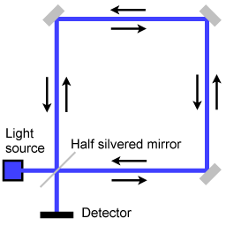](http://sensorwiki.org/lib/exe/detail.php/sensors/gyro_sagnac_interferometer.png?id=sensors%3Agyroscope&cache=cache)

## Specifications

A gyroscope sensor has the following basic specifications:

* Measurement range
* Number of sensing axes
* Nonlinearity
* Working temperature range
* Shock survivability
* Bandwidth
* Angular Random Walk (ARW)
* Bias
* Bias Drift
* Bias Instability

Measurement range – This parameter specifies the maximum angular speed with which the sensor can measure, and is typically in degrees per second (˚/sec).

Number of sensing axes – Gyroscopes are available that measure angular rotation in one, two, or three axes. Multi-axis sensing gyros have multiple single-axis gyros oriented orthogonal to one another. Vibrating structure gyroscopes are usually single-axis (yaw) gyros or dual-axis gyros, and rotary and optical gyroscope systems typically measure rotation in three axes.

Nonlinearity – Gyroscopes output a voltage proportional to the sensed angular rate. Nonlinearity is a measure of how close to linear the outputted voltage is proportional to the actual angular rate. Not considering the nonlinearity of a gyro can result in some error in measurement. Nonlinearity is measured as a percentage error from a linear fit over the full-scale range, or an error in parts per million (ppm).

Working temperature range – Most electronics only work in some range of temperatures. Operating temperatures for gyroscopes are quite large; their operating temperatures range from roughly -40˚C to anywhere between 70 and 200˚C and tend to be quite linear with temperature. Many gyroscopes are available with an onboard temperature sensor, so one does not need to worry about temperature related calibrations issues.

Shock Survivability – In systems where both linear acceleration and angular rotation rate are measured, it is important to know how much force the gyroscope can withstand before failing. Fortunately gyroscopes are very robust, and can withstand a very large shock (over a very short duration) without breaking. This is typically measured in g’s (1g = earth’s acceleration due to gravity), and occasionally the time with which the maximum g-force can be applied before the unit fails is also given.

Bandwidth – The bandwidth of a gyroscope typically measures how many measurements can be made per second. Thus the gyroscope bandwidth is usually quoted in Hz.

Angular Random Walk (ARW) - This is a measure of gyro noise and has units of deg/hour1/2 or deg/sec1/2. It can be thought of as the variation (or standard deviation), due to noise, of the result of integrating the output of a stationary gyro over time. So, for example, consider a gyro with an ARW of 1°/sec1/2 being integrated many times to derive an angular position measurement: For a stationary gyro, the ideal result - and also the average result - will be zero. But the longer the integration time, the greater will be the spread of the results away from the ideal zero. Being proportional to the square root of the integration time, this spread would be 1° after 1 second and 10° after 100 seconds.

Bias - The bias, or bias error, of a rate gyro is the signal output from the gyro when it is NOT experiencing any rotation. Even the most perfect gyros in the world have error sources and bias is one of these errors. Bias can be expressed as a voltage or a percentage of full scale output, but essentially it represents a rotational velocity (in degrees per second). Again, in a perfect world, one could make allowance for a fixed bias error. Unfortunately bias error tends to vary, both with temperature and over time.

The bias error of a gyro is due to a number of components:

* calibration errors
* switch-on to switch-on
* bias drift
* effects of shock (g level)

Individual measurements of bias are also affected by noise, which is why a meaningful bias measurement is always an averaged series of measurements.

Bias Drift - This refers specifically to the variation of the bias over time, assuming all other factors remain constant. Basically this is a warm-up effect, caused by the self heating of the gyro and its associated mechanical and electrical components. This effect would be expected to be more prevalent over the first few seconds after switch-on and to be almost non-existent after (say) five minutes.

Bias Instability - Bias Instability is a fundamental measure of the 'goodness' of a gyro. It is defined as the minimum point on the [Allan Variance](http://en.wikipedia.org/wiki/Allan%20Variance) curve, usually measured in °/hr. It represents the best bias stability that could be achieved for a given gyro, assuming that bias averaging takes place at the interval defined at the Allan Variance minimum

**Using a gyroscope with Microcontroller( Here I will be using Arduino for the explanation purpose)**

I am trying to explain the use and interfacing of the gyroscope with the Arduino by using a MPU6050 IMU sensor which houses both a gyroscope as well as an accelerometer on the same board

The MPU6050 uses the I2C communication protocol to send and receive the data from the microcontroller which we are using



The MPU-6050 is a serious little piece of motion processing tech! By combining a MEMS 3-axis gyroscope and a 3-axis accelerometer on the same silicon die together with an onboard Digital Motion Processor™ (DMP™) capable of processing complex 9-axis MotionFusion algorithms, the MPU-6050 does away with the cross-axis alignment problems that can creep up on discrete parts.

[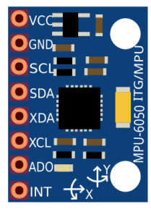](https://301o583r8shhildde3s0vcnh-wpengine.netdna-ssl.com/wp-content/uploads/2014/10/mpu6050-209x300.png)

*Arduino MPU 6050 Pin out*

### How Does it Work?

IMU sensors usually consist of two or more parts. Listing them by priority, they are the accelerometer, gyroscope, magnetometer, and altimeter. The MPU 6050 is a 6 DOF (Degrees of Freedom) or a six-axis IMU sensor, which means that it gives six values as output. Three values from the accelerometer and three from the gyroscope. The MPU 6050 is a sensor based on MEMS (Micro Electro Mechanical Systems) technology. Both the accelerometer and the gyroscope are embedded inside a single chip. This chip uses I2C (Inter-Integrated Circuit) protocol for communication.

### How Does a Gyroscope Work?

[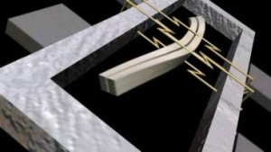](https://301o583r8shhildde3s0vcnh-wpengine.netdna-ssl.com/wp-content/uploads/2014/10/gyro-1024x576.jpg)

Piezo Electric Gyroscope

Gyroscopes work on the principle of Coriolis acceleration. Imagine that there is a fork-like structure that is in a constant back and forth motion. It is held in place using piezoelectric crystals. Whenever you try to tilt this arrangement, the crystals experience a force in the direction of inclination. This is caused as a result of the inertia of the moving fork. The crystals thus produce a current in consensus with the piezoelectric effect, and this current is amplified. The values are then refined by the host microcontroller. Check this short video that explains how a [MEMS gyroscope works](https://www.youtube.com/watch?v=zwe6LEYF0j8).

<https://www.youtube.com/watch?v=zwe6LEYF0j8>

### Interfacing the Arduino MPU 6050

The MPU 6050 communicates with the Arduino through the I2C protocol. The MPU 6050 is connected to Arduino as shown in the following diagram. If your MPU 6050 module has a 5V pin, then you can connect it to your Arduino’s 5V pin. If not, you will have to connect it to the 3.3V pin. Next, the GND of the Arduino is connected to the GND of the MPU 6050.

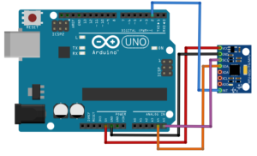

Arduino MPU 6050 connections

The program we will be running here, also takes advantage of the Arduino’s interrupt pin. Connect your Arduino’s digital pin 2 (interrupt pin 0) to the pin labeled as INT on the MPU 6050. Next, we need to set up the I2C lines. To do this, connect the pin labeled SDA on the MPU 6050 to the Arduino’s analog pin 4 (SDA) and the pin labeled as SCL on the MPU 6050 to the Arduino’s analog pin 5 (SCL).

### Uploading the Code and Testing the Arduino MPU 6050

To test the Arduino MPU 6050, first download the Arduino library for MPU 6050, developed by Jeff Rowberg. You can find the library [here](http://diyhacking.com/projects/MPU6050.zip). Next, you have to unzip/extract this library and take the folder named “MPU6050” and paste it inside the Arduino’s “library” folder. To do this, go to the location where you have installed Arduino (Arduino –> libraries) and paste it inside the libraries folder. You might also have to do the same thing to install the I2Cdev library if you don’t already have it for your Arduino. Do the same procedure as above to install it, you can find the file here: [I2Cdev](http://diyhacking.com/projects/I2Cdev.zip) library.

If you have done this correctly, when you open the Arduino IDE, you can see “MPU6050” in File –> Examples. Next, open the example program from: File –> Examples –> MPU6050 –> Examples –> MPU6050\_DMP6.

[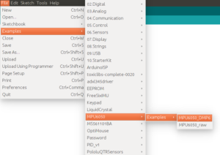](https://301o583r8shhildde3s0vcnh-wpengine.netdna-ssl.com/wp-content/uploads/2014/10/arduinoCode.png)

Arduino MPU 6050 DMP code

Next, you have to upload this code to your Arduino. After uploading the code, open up the serial monitor and set the baud rate as 115200. Next, check if you see stuff like “Initializing I2C devices…” on the serial monitor. If you don’t, just press the reset button. Now, you’ll see a line saying  “Send any character to begin DMP programming and demo.” Just type in any character on the serial monitor and send it and you should start seeing the yaw, pitch, and roll values coming in from the MPU 6050. Like so:

[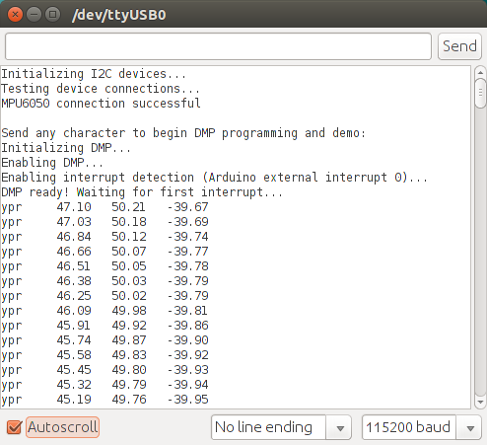](https://301o583r8shhildde3s0vcnh-wpengine.netdna-ssl.com/wp-content/uploads/2014/11/mpuSerial.png)

Arduino MPU 6050 Serial Monitor

DMP stands for Digital Motion Processing. The MPU 6050 has a built-in motion processor. It processes the values from the accelerometer and gyroscope to give us accurate 3D values.

Also, you will need to wait about 10 secs before you get accurate values from the Arduino MPU 6050. After which, the values will begin to stabilize.